Yawei shares dazzling debut of Asia's top sheet metal processing event
2017-10-22 Yawei laser equipment division
Yawei laser equipment department concerned click me yo
Regularly push Yawei laser hot information, new technology and new technology, use and maintenance of quality content! It's right to pay attention to us.
As a Chinese, not the the Great Wall is not a good man.
AsbyJin,MissBotswanaregret!
The nineteenth China International Industry Fair will be held in the National Convention and Exhibition Center (Shanghai) in from November 7 to 11, 2017. There will be 9 professional exhibitions. The exhibition area will be 280 thousand square meters. Over 2500 exhibitors will attend the exhibition. More than 160 thousand professional spectators will be visited. Among them, CNC machine tool and metal processing Exhibition (MWCS2017) is one of the top international machine tool professional exhibitions in China, focusing on machine tools, sheet metal and pipe processing, mold manufacturing, and related latest technology.
Then, Yawei shares will bring three new models of shocking debut, congratulate you to visit!

Yawei shares exhibition information
Booth number: 2H hall F008, Yawei shares
Exhibition time: November 7, 2017 - 11
Exhibition site: Shanghai National Convention and Exhibition Center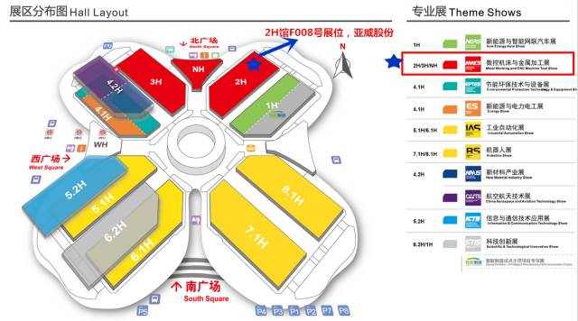

01
HLF1530 high speed optical fiber laser cutting machine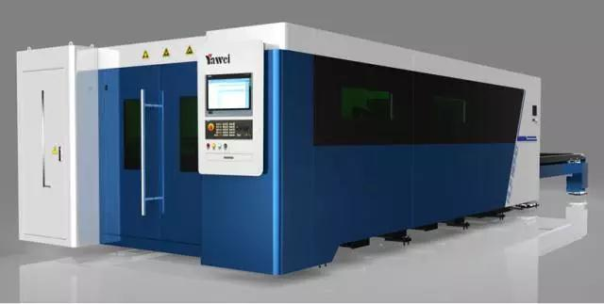
● A new generation of high speed fiber laser cutting machines at the international level
Longmen double zone bed structure, high strength aluminum alloy crossbeam, high efficiency automatic exchange table, production capacity multiplier
Ultra-high speed cutting of thin plates, high efficiency processing of medium and thick plates, and more extensive processing of metal materials
The advanced fusion of advanced laser technology and advanced digital control technology, the comprehensive upgrade of the humanized operation interface and the cutting expert parameter library
HLF-1530 fiber laser cutting machine is Yawei shares after years of development and innovation, the integration of the international most advanced laser technology, the highest price of the two-dimensional laser cutting machine; the Longmen double drive bed, through finite element analysis and optimization of high strength, lightweight beam design, light weight, low distortion, equipped with Germany ALPHA high precision gear and rigid complete sets of grinding gear rack, Japan THK precision linear guide, transmission mechanism, equipped with fiber laser, through the German SIEMENS original 840Dsl system, the faster and more efficient cutting speed, meet the needs of different industries and the needs of customers.
02
Precision bending unit
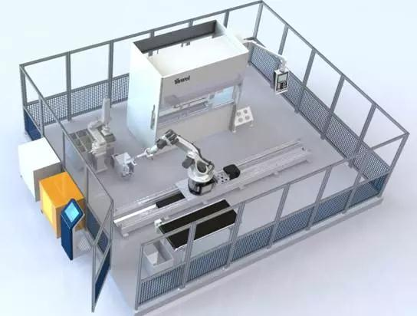
PBE0102FMC0 is more suitable for automatic bending of small parts, and it can automatically complete many complex parts. It is convenient for programming and quick in operation.
Yahweh - widely in the application of domestic robot bending unit, can provide flexible solutions for customers
- have Yawei series high - precision bending machine, high precision, can realize high precision robot, robot bending unit
The technical team has rich Yawei metal production experience, provide various schemes for your bending robot, you meet the processing requirements of complex products, heavy products
03
AMS.H-30510 NC sheet metal stamping processing system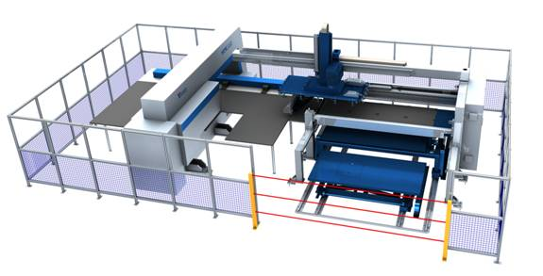
The sheet metal stamping processing unit integrates the stamping processing, feeding and discharging devices, and automatically completes the stamping and stacking of metal sheets. The advanced control system effectively integrates all the functional units and improves the efficiency of sheet metal processing to a new level.
Production time is short; preparation time is reduced; manual operation and processing are reduced; labor force is reduced.
High precision of parts
The increase of material utilization; efficient cutting; standard sheet size

To be a first-class international laser equipment and solution service provider
Yawei manufacturing experience of more than 60 years of precipitation, lean production management modernization, strategic cooperation supplier of world-class, full life cycle service, as your solution menace from the rear.
According to the two-dimensional code, Yawei laser equipment department concerned

